WAVERLEY PARK OPERATING ROOM

PRIVATE MINOR SURGERY - REFERRAL

Dr Paul M Newman/Dr Sheena Fraser, Waverley Park Operating Room,
19 Dinmont Road, Glasgow, G41 3UJ
Tel: 0141 632 8883, Fax: 0141 636 0654

Patient Identification Label  Referring GP | 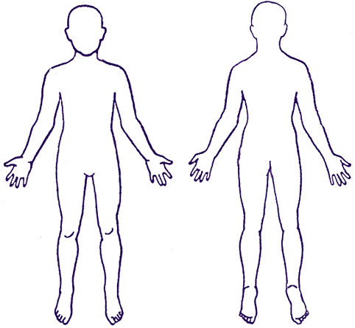  Please indicate the position of the lesion
ONLY AVAILABLE PRIVATELY AT WAVERLEY PARK OPERATING ROOM
Please tick below
Dermofibromas/ Lipomas
Cysts that have not been infected
Xanthelasmas
Benign Moles
Neurofibromas
Skin Tags
Any benign lesion

Referral Type | Private
Diagnosis

Reason for Referral

P.M.Hx

Rx

Allergies

High Risk Infection | YES NO | HIV Hep B Hep C

